CREATE TABLE studentdetails (

student_id INT PRIMARY KEY,

student_name VARCHAR(100),

grade VARCHAR(64)

);

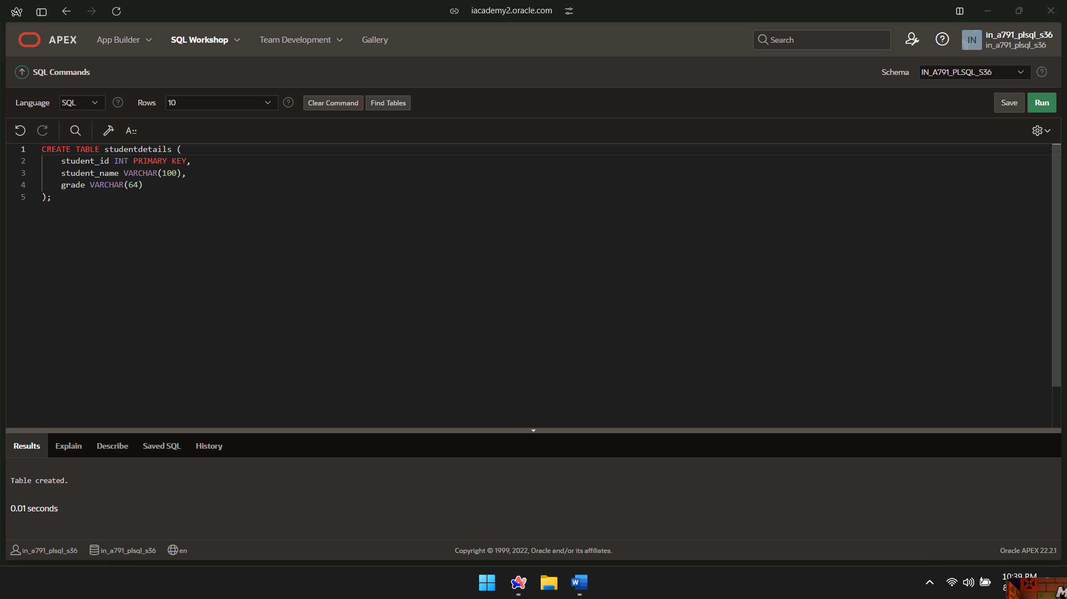

CREATE TABLE mark_details (

student_id INT,

subject VARCHAR(100),

marks INT,

FOREIGN KEY (student_id) REFERENCES studentdetails(student_id)

);

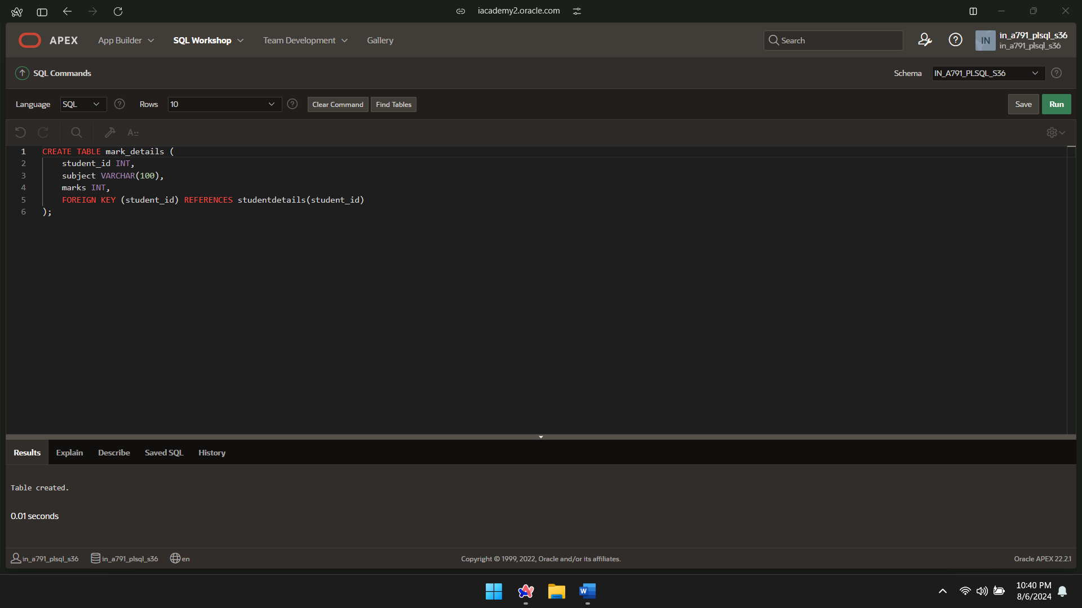

INSERT INTO studentdetails (student_id, student_name) VALUES (1, 'Name1');

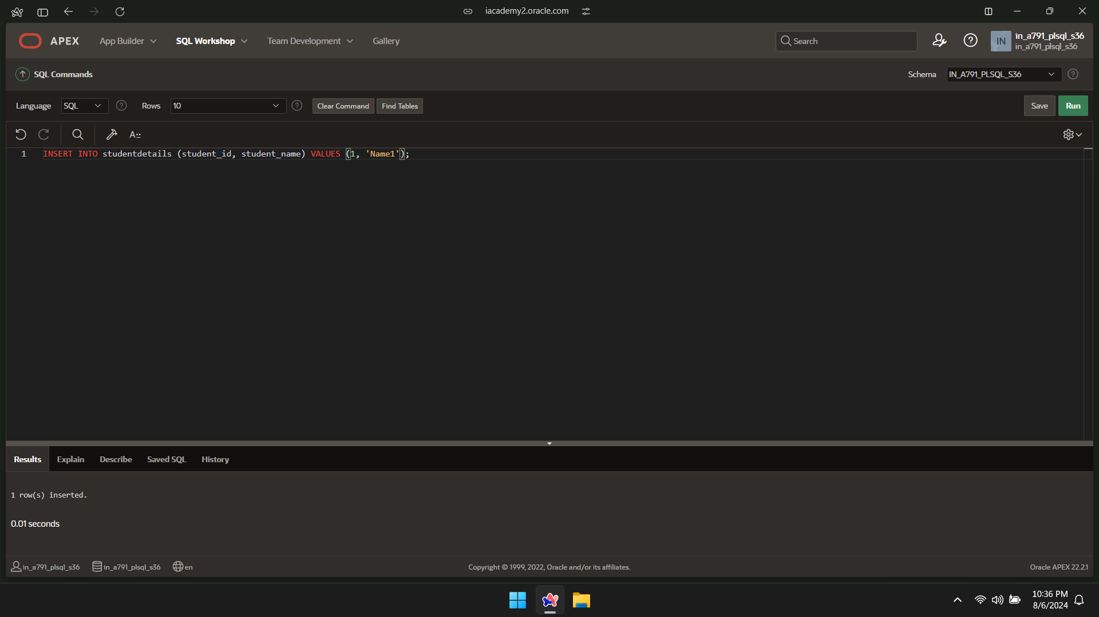

INSERT INTO studentdetails (student_id, student_name) VALUES (2, 'Name2');

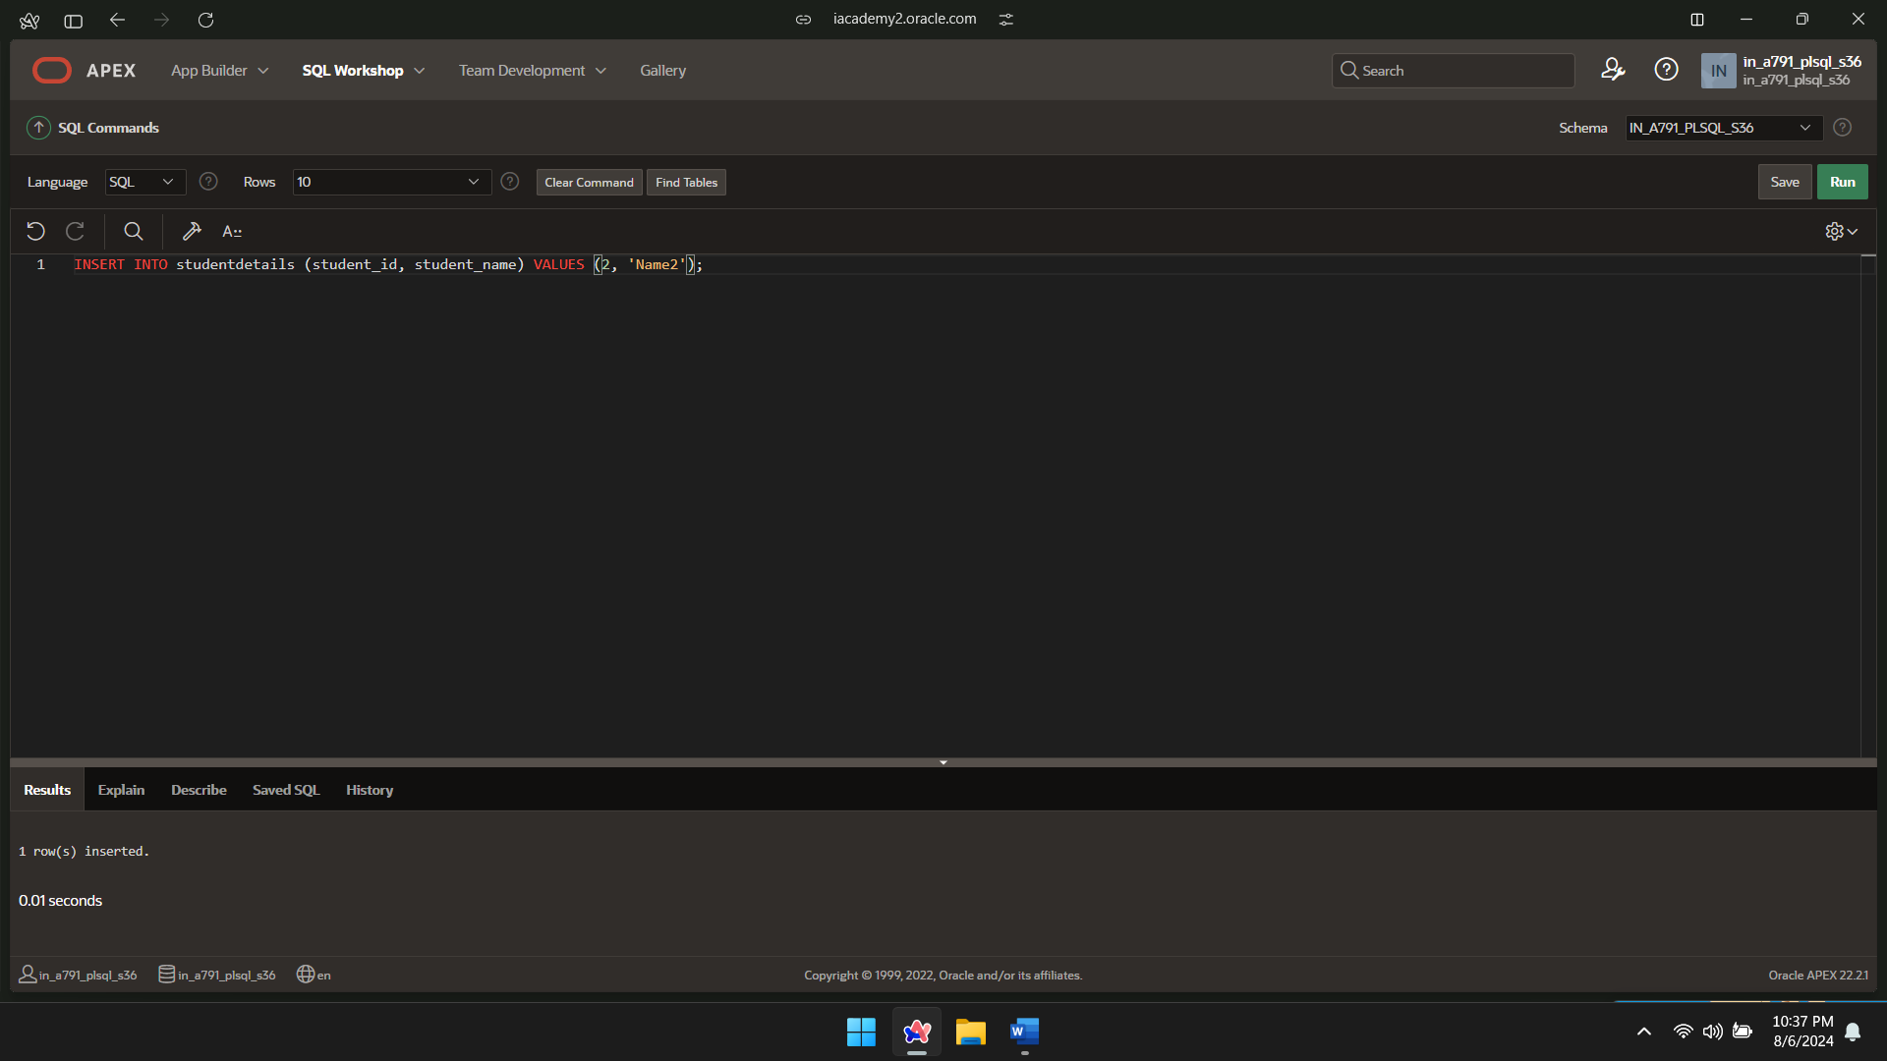

INSERT INTO studentdetails (student_id, student_name) VALUES (3, 'Name3');

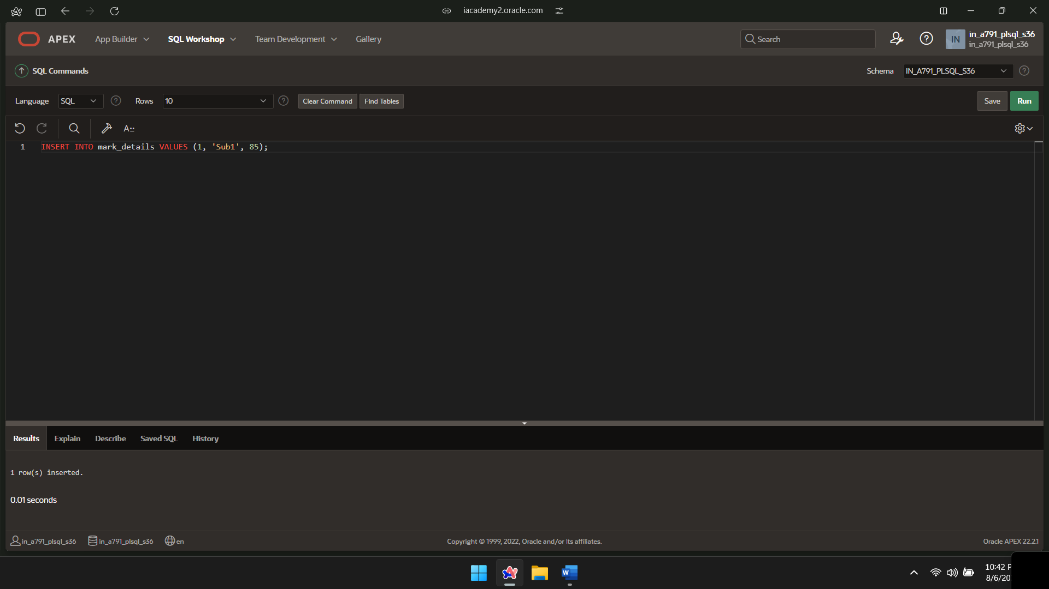

INSERT INTO mark_details VALUES (1, 'Sub2', 91);

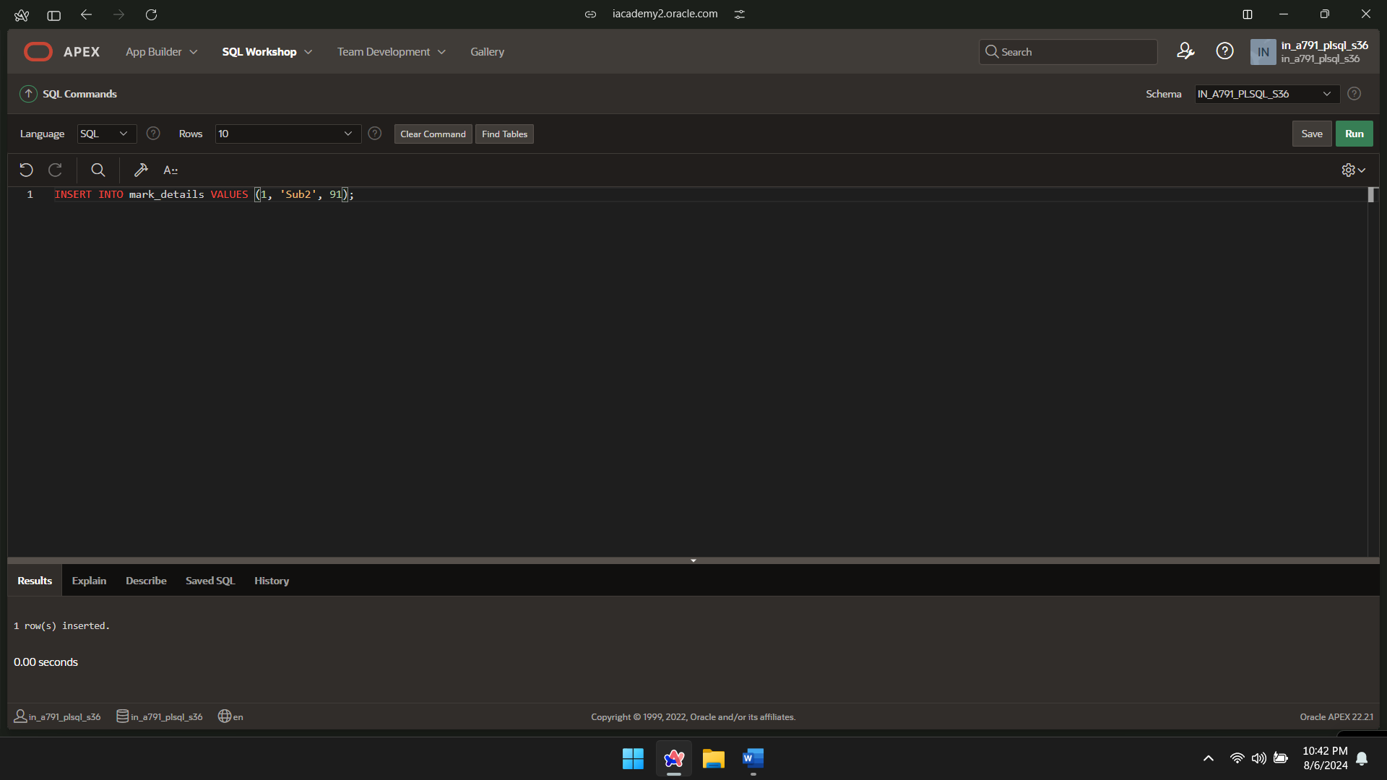

INSERT INTO mark_details VALUES (2, 'Sub1', 82);

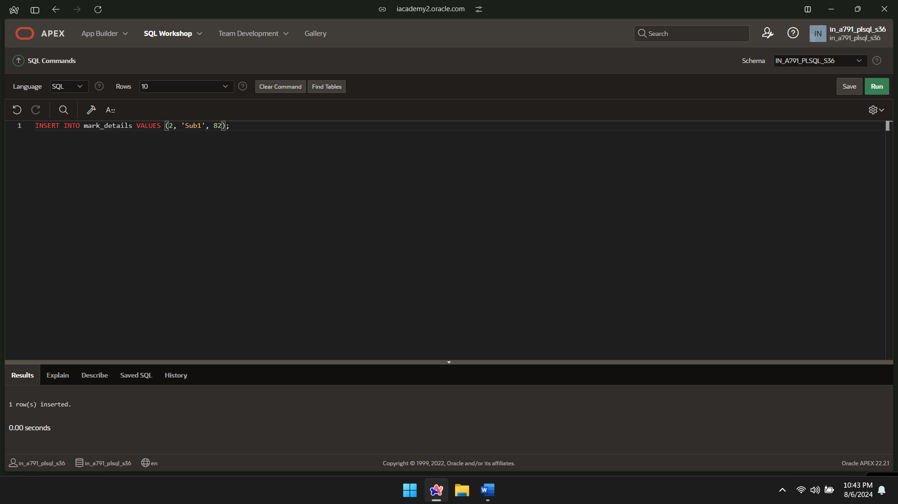

INSERT INTO mark_details VALUES (2, 'Sub2', 78);

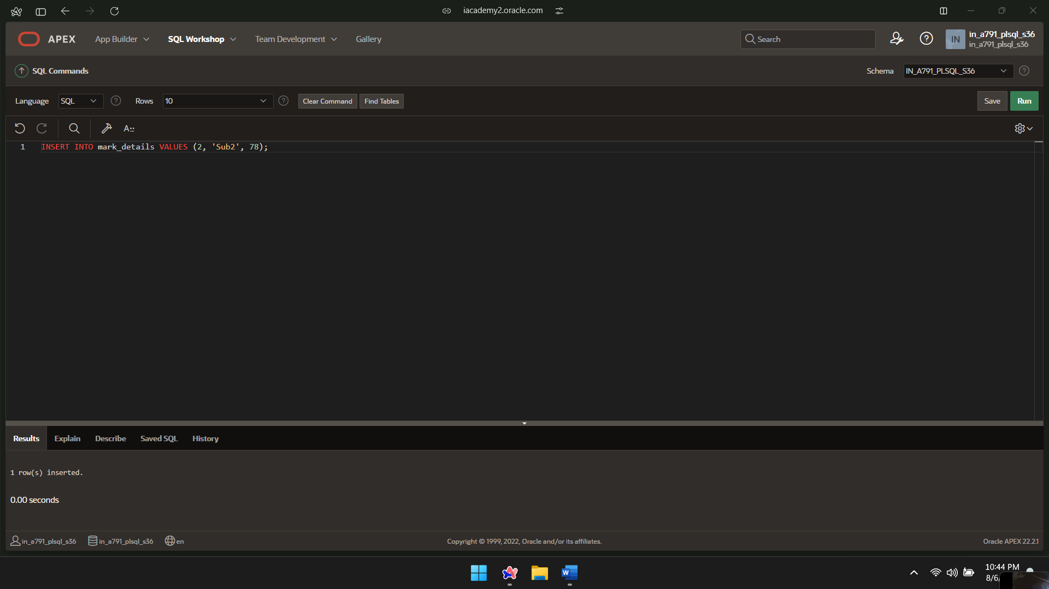

INSERT INTO mark_details VALUES (3, 'Sub1', 83);

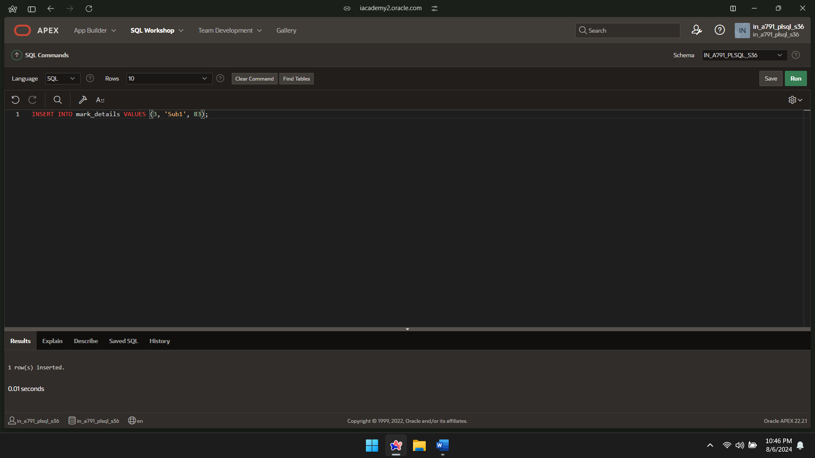

INSERT INTO mark_details VALUES (3, 'Sub2', 91);

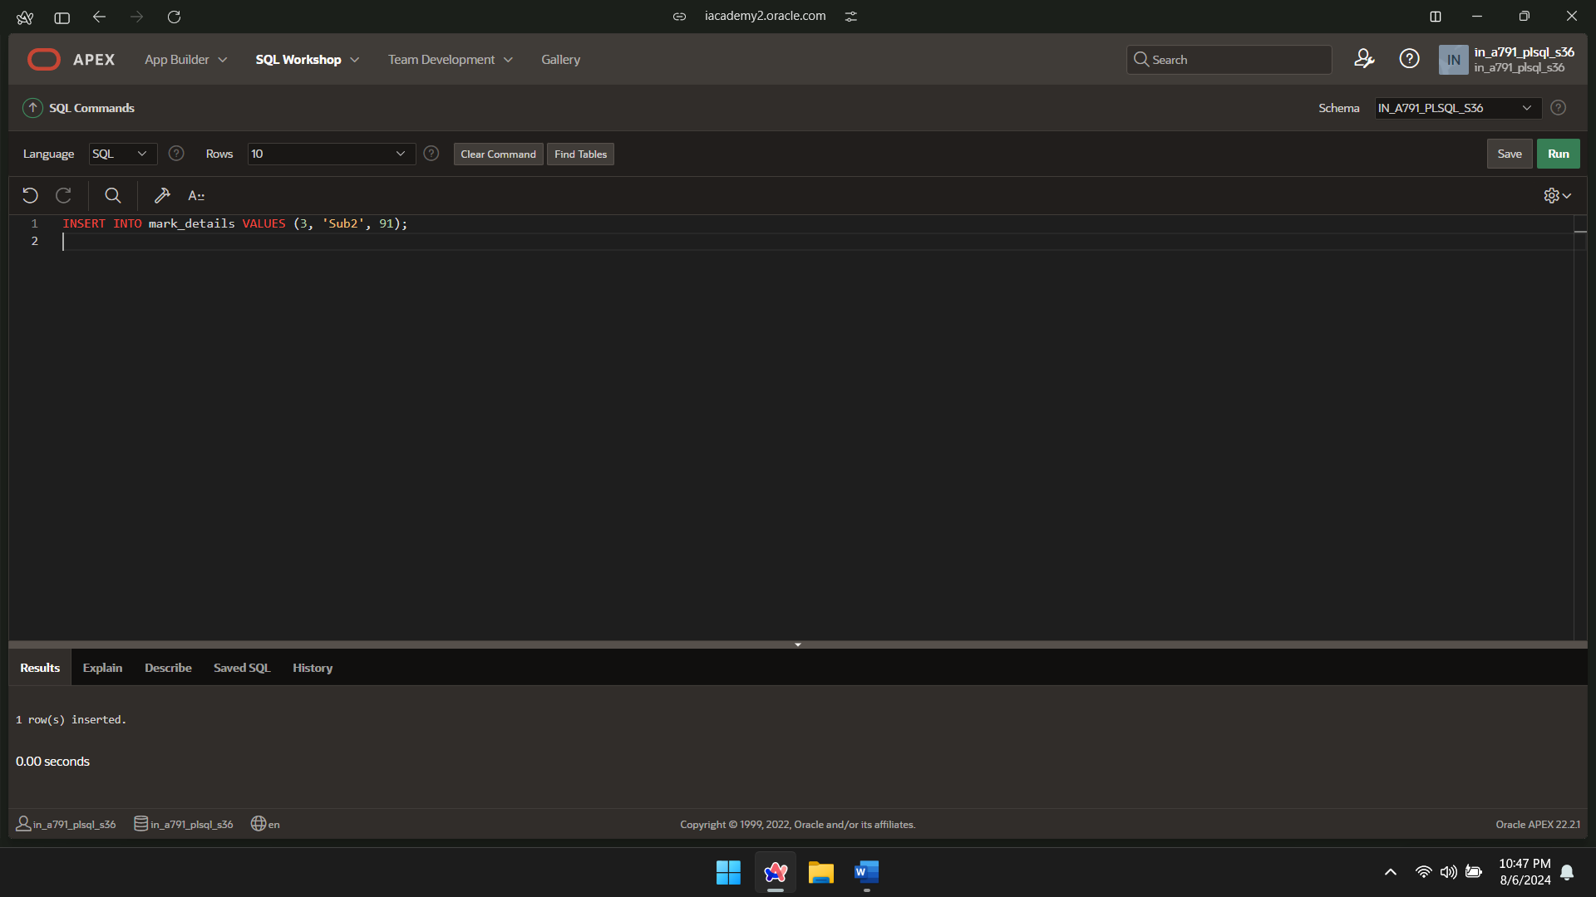

DECLARE

CURSOR student_cursor IS

SELECT student_id

FROM mark_details

GROUP BY student_id;

v_student_id mark_details.student_id%TYPE;

v_avg_marks FLOAT;

v_grade VARCHAR(64);

BEGIN

OPEN student_cursor;

LOOP

FETCH student_cursor INTO v_student_id;

EXIT WHEN student_cursor%NOTFOUND;

SELECT AVG(marks) INTO v_avg_marks

FROM mark_details

WHERE student_id = v_student_id;

IF v_avg_marks >= 80 THEN

v_grade := 'Distinction';

ELSIF v_avg_marks >= 60 THEN

v_grade := 'First Class';

ELSIF v_avg_marks >= 50 THEN

v_grade := 'Second Class';

ELSE

v_grade := 'Fail';

END IF;

UPDATE studentdetails

SET grade = v_grade

WHERE student_id = v_student_id;

END LOOP;

CLOSE student_cursor;

END;

/

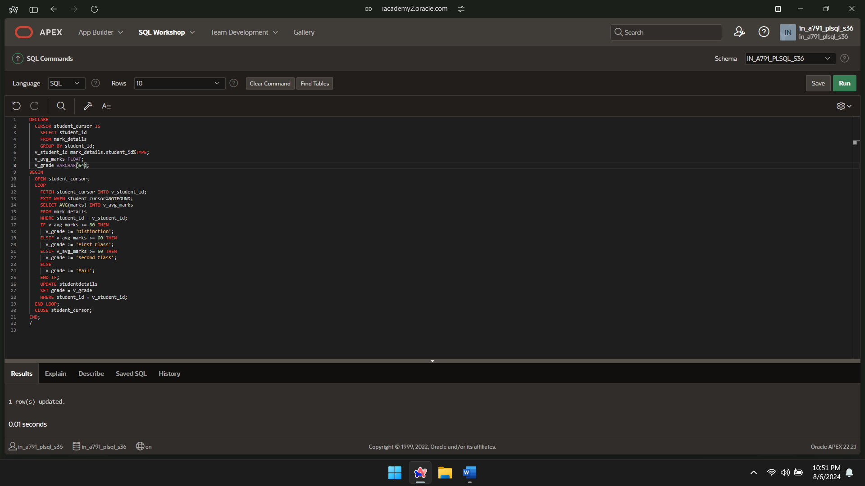

SELECT*FROM STUDENTDETAILS;

